POSTS AND TELECOMMUNICATIONS INSTITUTUTE OF TECHNOLOGY
DEPARTMENT OF INFORMATION TECHNOLOGY 1


ASSIGNMENT REPORT
Subject name: Introduction to Software Engineering
Classname: D23CQCE05-B
Project name: F1 Formula Championship Management
Project code: 10
Group code: 9
Member list: 1. Đoàn Hoàng Nam – B23DCCE068
2. Phạm Văn Nhất – B23DCCE074
3. Nguyễn Vũ Quang – B23DCVT363
4. Phạm Xuân Thắng – B23DCCE089
Requirements: Analysis – Update Module

Hanoi – 2026
I. Glossary list
No | Concept (EN) | Concept (VI) | Meaning
Concept related to human
1 | Rider/Driver | Tay đua | The person directly controlling the race car in the competition. Attributes include: ID, name, date of birth, nationality, and biography.
2 | Team Owner | Chủ đội đua | The owner or highest legal representative of the racing team. The owner's name is displayed in the "Team Standings" function.
3 | Staff | Nhân viên vận hành | Software users who perform tasks: Registering drivers (Register), Updating results (Update results), and Viewing statistics (View statistics).
4 | Participating Team | Đội tham gia | A collective of members and vehicles representing a brand. Each team has an ID, Name, Brand, and Description.
5 | Teammate | Đồng đội | The other driver within the same racing team at a specific race (as each team can register a maximum of 2 people).
6 | Race Director | Giám đốc đường đua | The highest authority in managing safety and regulations at the race, deciding on flags and safety cars.
7 | Steward | Trọng tài | A group of officials responsible for handling rule violations and issuing penalties to drivers or teams.
8 | Pit Crew | Đội ngũ kỹ thuật Pit | A group of mechanics who perform tire changes and repairs while the car is stopped in the Box (Pit stop).
9 | Marshal | Nhân viên đường đua | Personnel stationed at posts around the track to wave signal flags and assist during incidents.
10 | Grid Marshal | Nhân viên khu vực xuất phát | Personnel ensuring cars are correctly positioned on the starting grid before the race begins.
11 | Scrutineer | Nhân viên kiểm tra kỹ thuật | Personnel who check the technical specifications of the car before and after the race to ensure compliance with regulations.
12 | Safety Car Driver | Người lái xe an toàn | A professional driver who operates the Safety Car to lead the field during incidents.
13 | Medical Staff | Đội ngũ y tế | Doctors and medical personnel on standby at the track to provide first aid in case of accidents.
14 | Team Principal | Lãnh đội | The person managing strategy and directly overseeing the team's operations at the track.
15 | Test Driver | Tay đua thử nghiệm | A reserve driver or specialist who drives to collect data for car development; does not race officially unless replacing someone.
16 | Spectator | Khán giả | People watching directly at the circuit or via live television broadcast.
17 | Backmarker | Tay đua bị bắt vòng | A slower driver who is being overtaken (lapped) by the leader; usually must yield when seeing a blue flag.
18 | Pole Sitter | Người giành Pole | The driver starting in the first position (Pole position) thanks to the best performance in the qualifying session.
19 | Rookie | Tân binh | A driver participating in the championship for their first season.
Concept related to object
20 | Tournament/  Championship | Giải vô địch / Mùa giải | An annual competition system consisting of multiple races worldwide to find the individual and team champions.
21 | Race/Grand Prix | Chặng đua | A specific racing event.
22 | Race Code | Mã chặng đua | A unique string of characters identifying a specific race within the database system.
23 | Circuit/Track | Trường đua | The physical location hosting the race, including the asphalt track and auxiliary structures.
24 | F1 Car | Xe đua F1 | A standard competition vehicle with open-wheel design, complying with the technical regulations of the championship.
25 | Lap | Vòng đua | A single closed circuit around the track. The number of laps is an important attribute of a race.
26 | Start/Finish Line | Vạch xuất phát/đích | The line on the track marking the beginning and end of a lap.
27 | Pit Lane | Làn Pit | A road running parallel to the main track, where the teams' repair garages are located.
28 | Pit Box | Ô kỹ thuật | A specific spot in front of the garage where the car stops for tire changes.
29 | Paddock | Khu vực hậu cần | The area behind the Pit lane, housing the management center and living quarters for the teams.
30 | Safety Car (SC) | Xe an toàn | A high-performance vehicle deployed onto the track to slow down the field when there is danger.
31 | Virtual Safety Car (VSC) | Xe an toàn ảo | A signal requiring drivers to reduce speed according to regulations without the actual safety car appearing.
32 | Chequered Flag | Cờ ca-rô (Cờ đích) | A black and white checkered flag signaling the end of a race or session.
33 | Red Flag | Cờ đỏ | A signal to immediately stop the race due to a serious accident or severe weather.
34 | Yellow Flag | Cờ vàng | A warning signal of danger, requiring drivers to slow down and prohibiting overtaking.
35 | Blue Flag | Cờ xanh dương | A signal requiring a slower driver (Backmarker) to yield to a faster car that is about to overtake them.
36 | Green Flag | Cờ xanh lá | A signal indicating the track is safe, allowing drivers to accelerate and overtake.
37 | Black Flag | Cờ đen | A signal to disqualify a specific driver from the race.
38 | Slick Tyre | Lốp trơn | Tires used for dry tracks, having no treads to maximize the contact area.
39 | Wet Tyre | Lốp đi mưa | Tires with deep treads used to disperse water during heavy rain.
40 | Intermediate Tyre | Lốp trung gian | Tires used for damp conditions or light rain.
41 | Compound | Hợp chất lốp | The rubber composition (Soft, Medium, Hard) affecting the grip and durability of the tire.
42 | Steering Wheel | Vô lăng | A device used to control direction and integrate a display screen for technical parameters.
43 | Cockpit | Buồng lái | The open compartment where the driver sits to control the car.
44 | Chassis | Khung gầm | The main load-bearing frame of the car, protecting the driver.
45 | Halo | Khung bảo vệ Halo | A curved titanium bar surrounding the cockpit to protect the driver's head.
46 | Sidepod | Hốc gió hông | Components on both sides of the car containing radiators and directing airflow.
47 | Front Wing | Cánh gió trước | An aerodynamic component at the nose of the car that helps create downforce.
48 | Rear Wing | Cánh gió sau | An aerodynamic component at the rear, where the DRS system is usually integrated.
49 | DRS | Hệ thống giảm lực cản | An adjustable rear wing that opens to reduce air resistance, helping to increase speed when overtaking.
50 | Airbox | Hốc hút gió động cơ | An air intake located above the driver's head to supply air to the engine.
51 | Kerb/  Rumblestrip | Gờ đường đua | Raised edges (often painted red and white) at corners to signal the edge of the track.
52 | Gravel Trap | Bẫy sỏi | Areas of gravel outside the track to slow down cars when they lose control and slide off.
53 | Tecpro Barrier | Rào chắn Tecpro | Modern barriers designed to absorb impact forces, replacing old tire walls.
54 | Telemetry | Hệ thống đo lường từ xa | Technical data transmitted directly from the car to the technical team's computers.
55 | Standings | Bảng xếp hạng | A summary table of performance (points and time) for Drivers or Teams across races.
56 | Podium | Bục nhận giải | The honorary platform where trophies are awarded to the top finishers.
57 | Database | Cơ sở dữ liệu | Where the software system stores registration info, race results, and competition history.
58 | Interface | Giao diện | The software screen where staff perform registration tasks or view reports.
59 | Drop-down List | Danh sách thả xuống | An interface component used to select the Race Name or Team Name during registration/data entry.
Concept related to activity
60 | Register to racing | Đăng ký thi đấu | The process where staff select a Race, select a Team, and check 2 participating drivers into the system.
61 | Update Results | Cập nhật kết quả | The action of entering the Finish Time and Number of Laps completed for each driver after the race ends.
62 | Save Information | Lưu thông tin | The action of recording data (registration or results) into the database after the staff clicks the Save button.
63 | Select driver | Chọn tay đua | The action of marking/selecting exactly 2 drivers from the team's existing list.
64 | View Statistics | Xem thống kê | The action of retrieving and displaying Driver or Team standings.
65 | View Racer’s/  Team’s play history | Xem lịch sử đua của đội đua/tay đua | The action of selecting a row (driver/team) to view detailed competition history.
66 | Sort | Sắp xếp | The system action of automatically ordering: Points descending -> Time ascending.
67 | Finish | Về đích | Completing the required number of laps and crossing the finish line to record the time.
68 | Dropout/Retire (DNF) | Bỏ cuộc | Stopping mid-race due to technical issues or an accident. Recorded as 0 points.
69 | Accident | Tai nạn | A collision on the track that prevents a driver from continuing, resulting in 0 points.
70 | Calculate | Tính toán | The system automatically calculating points based on the finishing rank (1-10).
71 | Start | Xuất phát | The moment the race begins when the signal lights go out.
72 | Pit Stop | Vào Pit | The action of bringing the car into the technical area for tire changes or repairs.
73 | Overtake | Vượt xe | The action of a car behind passing a car in front to gain a better position.
74 | Lap (Verb) | Bắt vòng | The action of the lead car passing a slower car by a full lap.
75 | Lock-up | Khóa bánh | A situation where heavy braking causes tires to stop rotating and slide on the track surface, damaging the tires.
76 | Oversteer | Dư lái | A phenomenon where the rear of the car slides outwards during a corner (steering too much).
77 | Understeer | Thiếu lái | A phenomenon where the front of the car does not turn into the corner as intended, tending to slide straight.
78 | Slipstream | Núp gió | A technique of driving closely behind the lead car to reduce air resistance, preparing to overtake.
79 | Undercut | Chiến thuật Undercut | Pitting earlier than an opponent to exploit new tires for faster laps and overtake when the opponent pits later.
80 | Overcut | Chiến thuật Overcut | Pitting later than an opponent, exploiting a clear track to drive faster before entering for a tire change.
81 | Lift and Coast | Nhả ga trôi xe | A technique of releasing the accelerator early before braking to save fuel.
82 | Scrutineering | Kiểm tra kỹ thuật | The process where stewards inspect cars to see if they violate any standards.
83 | Accumulate | Cộng dồn | The system action of totaling points and time across races to rank the season.
84 | Select | Chọn lựa | The staff action of choosing a race or team from the available list.
85 | Display | Hiển thị | The system outputting data to the screen (in table format) for the user to view.
86 | Box, Box | Lệnh vào Pit | An order via radio from the team requiring the driver to enter for a tire change immediately.
87 | Aquaplaning | Trượt nước | A phenomenon where tires lose all grip when driving over puddles, causing loss of control.
88 | Blistering | Rộp lốp | A phenomenon where tire rubber overheats and peels off in patches.
89 | Graining | Sần lốp | A phenomenon where rubber bits peel off and then stick back to the tire surface, reducing grip.
Concept related to law/policy
90 | Scoring System | Hệ thống tính điểm | Rules for awarding points only to the Top 10 finishers: 25, 18, 15, 12, 10, 8, 6, 4, 2, 1.
91 | DNF Scoring Rule | Không hoàn thành | If a driver is in the Top 10 but retires (Dropout/Accident), they receive 0 points.
92 | Ranking Criteria | Tiêu chí xếp hạng | Ranking based on Total Points (descending). If points are equal, Total Time (ascending) is considered.
93 | Team Participation Limit | Giới hạn thành viên trong đội đua | In each race, a team is only allowed to register a maximum of 2 participating drivers.
94 | Transfer Rule | Luật chuyển nhượng | A driver can play for different teams at different times, but at any single moment, they can only compete for one team.
95 | Curfew | Giờ giới nghiêm | Regulations prohibiting team personnel from working at the track at night to ensure health.
96 | Result Ranking | Xếp hạng kết quả chặng | In each race, results are ranked based on finish time (the person with the least time ranks first).
97 | Season Prize | Giải thưởng mùa giải | Decided based on the accumulated total points and total time across all races.
98 | Pit Lane Speed Limit | Tốc độ giới hạn Pit | Regulations on the maximum velocity (usually 80km/h) when cars drive in the Pit lane.
99 | Track Limits | Giới hạn đường đua | Regulations stating cars must stay within the white boundary lines.
100 | Parc Fermé Rule | Luật Parc Fermé | Prohibits teams from working on or repairing cars after qualifying and before the race.
101 | Unsafe Release | Thả xe không an toàn | Penalizing a team for letting a car leave its pit box when it endangers other cars.
102 | Jump Start | Xuất phát sớm | A foul where a car moves before the signal lights go out.
103 | Blue Flag Rule | Luật cờ xanh | A lapped car must yield the way as soon as possible.
104 | Superlicence | Bằng lái siêu cấp | A mandatory license issued by the FIA for a driver to be allowed to participate.
105 | Constructors' Points | Điểm đội đua | The sum of points from the drivers in a team, used to rank the teams.
106 | Safety Car Lines | Vạch xe an toàn | Lines defining the position where overtaking is allowed or the race restarts after the safety car leaves.
107 | DRS Zone | Vùng DRS | A stretch of track where DRS activation is permitted if the gap to the car ahead is under 1 second.
108 | Detection Point | Điểm đo khoảng cách | The location where the gap between 2 cars is measured to determine if DRS can be used.
109 | Formation Lap Rule | Luật vòng khởi động | Cars are not allowed to overtake each other during the formation lap unless the car ahead has an issue.
110 | Weighbridge | Cân xe | Regulations requiring cars to be weighed randomly or mandatorily after racing to ensure minimum weight.
111 | Minimum Weight | Trọng lượng tối thiểu | The car and driver must reach a minimum weight (approx 798kg) at all times.
112 | Tyre Allocation | Phân bổ lốp | Each driver has a limited number of tire sets for each race (Hard, Medium, Soft).
113 | Mandatory Pit Stop | Pit Stop bắt buộc | In a dry race, a driver is mandatory to use at least 2 different tire compounds (meaning at least one pit stop).
114 | Fuel Flow Limit | Giới hạn dòng nhiên liệu | Regulations on the maximum amount of fuel pumped into the engine to control power output.

II. Business model in natural language
1. Objective and scope
- This is a desktop-based application which will be internally used by the F1 Championship organizers.
- This application supports the management for the annual F1 Championship season.
- Staffs can use this application.
- This application could be installed on many computers of the staffs. However, the database is stocked on the organization server.

2. User and functions that each user could use
- The application is only designed for the F1 Formula Championship Management staffs.
- All staff can use the following functions:
- Update race results:
- The time to finish line
- The number of laps completed
- Choose dnf/accident/finished
- Register racing:
- Select the races
- Select a racing team
- Tick the correct 2 racers according to the team’s request
- View races’ standings:
- Display a list of racers in the form of a table, sorted by total score after the selected stages (descending) and then by total time after stages (ascending).
- Display the detailed results of each race stage given by that racer.
- View the team rankings:
- Display a list of racing teams in the form of a table, sorted by total score (descending) and then by total time (ascending).
- Display detailed results for each stage of that racing team.

3. Detailed business process of function
Module 1: Register to racing
- A staff/manager logs into the system -> The staff’s UI appears with function options: Manage races, Manage teams, Register to racing, Update results, and Statistics -> The staff selects the Register to racing function.
- The system displays the racer registration interface with drop-down lists for "Race/Stage" and "Racing Team".
- The staff selects a specific Race/Stage and a specific Racing Team from the lists:
- The system loads and displays a list of all drivers currently belonging to the selected team.
- The list is sorted by their alphabetic order of name.
- The system displays the list of drivers in the form of a list with checkboxes. Each row contains:
- Driver name
- Selection checkbox
- The staff ticks the checkboxes next to the drivers to register (Constraint: The staff must tick exactly 1 or 2 drivers according to the team's request. Max 2 drivers per team).
- The staff clicks on the Save button:
- The system validates the data. If the staff selects 0 or more than 2 drivers, the system displays an error message.
- If the data is valid (1 or 2 drivers selected), the system announces a success alert and saves the registration information to the database.
Module 2: Update Results
- The staff member selects the "Update Results" function
- The system displays the result input interface featuring a drop-down list for the "Race Name."
- The staff selects a specific race from the drop-down list
- The system retrieves and displays a table of all racers registered for that specific race. Each row includes fields for:
- Racer Name
- Team
- Time to Finish (Blank text box for HH:mm:ss format)
- Laps Completed (Blank box for numerical input)
- Finished Status/DNF/Accident (Checkbox)
- The staff enters the performance data for all racers
- The staff fills in the completion time and the total number of laps for every participant on the list.
- The staff clicks the "Save" button
- The system performs the following background actions:
- Data Validation: Checks for correct time formatting and valid lap numbers.
- Auto-Ranking: Calculates the rank for each racer based on Finished status, Laps completed, and Total time.
- Database Update: Records the results and the calculated ranks into the system database.
- The system displays a success notification
Module 3: View the Racer’s Standings
- The staff member selects the "Statistics" function → select "Current Racer Rankings".
- The system displays the races and timeline in the format "XXX – dd/MM/yyyy" (e.g: Alaska – 17/02/2012) → the staff member selects a race:
- If the staff member selects a race that has not yet taken place (scheduled date is greater than the current date) → the system alerts: "The race has not taken place. Please return after the race has concluded on the scheduled date" → return to select another race.
- If the staff member selects a race that has already taken place → the system displays a list of racers in the form of a table; each line contains:
- Racer’s Name
- Nationality
- Team Name
- Total Score (after the selected stages)
- Total Time (after the selected stages).
(Note: The information is sorted in descending order of total points, then in ascending order of total time).
- The staff member selects a line of a racer → the system displays the detailed results of each race stage given by that racer; each race stage includes:
- Stage Name
- Finish Rank
- Score
- Time to Finish.
- The staff member can press "Back" to view other related information.
Module 4: View the team rankings
- A staff member selects the Statistics function ->The staff then selects the View the team rankings option.
- The staff selects a stage from the drop-down list:
- If the selected stage has not yet occurred or the race results have not been entered, the system displays the message: “The race has not taken place. Please return after the race has concluded on the scheduled date.”
- If data is available, the system calculate the total score and total time of each racing team from the beginning of the season to the selected stage. The system then displays a list of racing teams in the form of a table. Each row contains:
- Team name
- Brand
- Total points of the team’s driver
- Total time after stages.
(The table is sorted in descending order of total points and, if necessary, in ascending order of total time)
- When the staff clicks on a team in the table, the system displays the detailed results of that team for each stage. Each row contains:
- Race name
- Total score of the team
- Total time of drivers
- After viewing the information, the staff can return to the previous screen to select another stage or access other system functions

4. Information about related objects
- Season: Name, year, start date, end date, description.
- Race Stage: Race code, name, number of laps, location (circuit), date/time, description, stage order.
- Racing Team: Team code, name, brand, description.
- Racer / Driver: Driver code, name, date of birth, nationality, biography, status (Active/Injured/Suspended).
- Race Registration: Registration ID, race code, team code, driver code, registration timestamp.
- Race Result: Finishing rank (1st, 2nd, etc.), total time (finishing time), number of laps completed, completion status (Finished/DNF/Accident), points awarded.
- Statistic on Driver Standings: Driver name, nationality, team name, total races participated, total points, total accumulated time, current rank.
- Statistic on Team Standings: Team name, manufacturer, total accumulated points of all team drivers, total accumulated time, current rank.

5. Relationships between information objects
- A Season has many Race Stages. A race stage belongs to exactly one season.
- A Season involves many Teams. A team can participate in many seasons.
- A Team consists of many Drivers. A driver belongs to a team via a contract for a specific period (season).
- A Driver can compete for different teams across different seasons, but usually only one team at a time within a specific race.
- Each Race Stage has many Driver Registrations.
- The "Rule of Two": A team can register a maximum of two drivers for a single race stage.
- A Registration is valid if and only if:
- The driver status is ACTIVE
- The driver has a valid contract with the team for that season.
- The team has not yet reached its limit of 2 registered drivers for that stage.
- A Result is automatically calculated by the system (Trigger): Points are awarded based on the Finishing Rank once the status is marked as finished.
III. Use case
Build the general use case diagram
Step 1:
- Direct actor: Staff this is the only user role explicitly mentioned as performing the tasks.
- Indirect actors: None are required for the diagram
Step 2 and 3:
The Staff could use the following functions:
- Select drivers for a specific team and race -> Register Racing.
- Enter the finish time and laps for drivers -> Update Results.
- View the accumulated points and times for individual drivers -> View Racers' Standings.
- View the accumulated points and times for racing teams -> View Team Rankings
The obtained general use case diagram is:
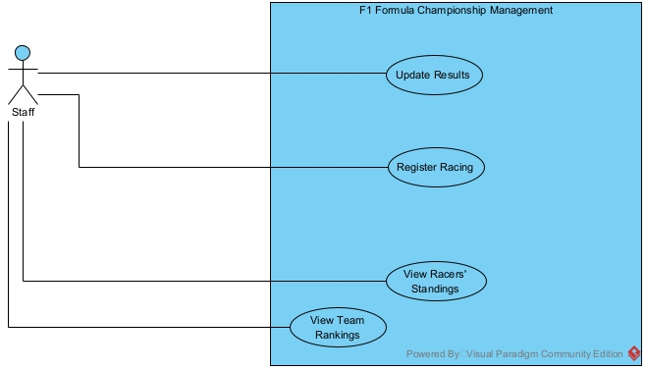
The use case are described as follow:
- Register Racing: This use case enables the Staff to select a maximum of 2 racers per team to participate in a specific race stage.
- Update Results: This use case allows the Staff to record finish times, finished status, and the number of completed laps for racers after each stage.
- View Racers' Standings: This use case enables the Staff to track racer rankings based on total points and time accumulated after stages.
- View Team Rankings: This use case allows the Staff to view the overall rankings of racing teams based on the accumulated points and times of their drivers.

Detailed Use Case: Update Results
Let's review the description of this function: The staff member logins and selects the "Update Results" function -> The system displays the result input interface featuring a drop-down list for the "Race Name" -> The staff selects a specific race from the drop-down list -> The system retrieves and displays a table of all racers registered for that specific race -> The staff enters the performance data for all racers -> The staff clicks the "Save" button -> The system performs background actions including data validation , auto-ranking , and database update.
So, in order to update the results, the staff has to: select the race to populate the interface with registered racers , input the performance metrics for each racer , and click save. Clicking save triggers the system to validate the data, auto-calculate the ranks based on completion, and update the database. We will use <<Include>> relationships because these sub-steps are mandatory parts of completing the result update process.

Use Case Description:
• Update Results (Main): This use case enables the staff to record the performance data of racers after a stage concludes. Upon completion, the system automatically validates inputs, calculates ranks, assigns scores based on the top 10 rules (25, 18, 15...), and records the final results into the database.
• Choose Race: This use case enables the staff to specify the race name from a drop-down list to retrieve the correct table of registered drivers. (Mandatory inclusion).
• Enter Results: This use case enables the staff to input the time to the finish line and laps completed for all listed racers in the provided table, and finalize the process by clicking the Save button. (Mandatory inclusion).
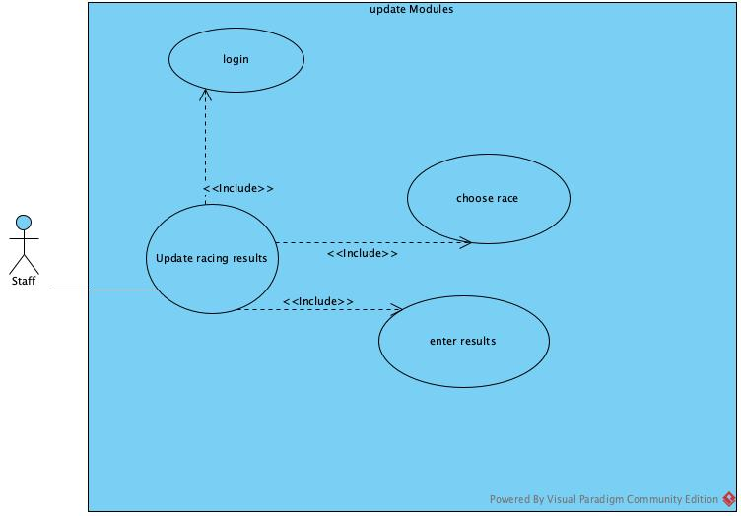

IV. Scenarios

scenerio | Update results
Pre-condition | The staff member has access to the system. Drivers must have been previously registered for the selected race stage.
Post-condition | The finish times, laps completed, calculated ranks, and awarded points for all racers are successfully saved to the database.
Standard scenario | A staff member wants to enter the final results after the "Monaco Grand Prix" has concluded.  - The staff selects the "Update results" function in the main UI.  - The result input interface is appeared with: a drop-down list for Race Name and a Save button. Below is a list  • Bahrain Grand Prix  • Monaco Grand Prix  • British Grand Prix  • Japanese Grand Prix  • Abu Dhabi Grand Prix  - The staff selects "Monaco Grand Prix" from the drop-down list.  - A list of all registered racers for this race is appeared in the form of a table, with blank input boxes:  Racer name team Time to finish Laps completed DNF/Accident/Finished  Charles Leclerc Ferrari 01:11:20 12 DNF  Max Verstappen Red Bull 02:12:20 21 Finished  Messi Argentian super 1:09:11 14 Accident  Ronaldo Portu 2:01:11 21 Finished  Reus Germen 1:20:43 16 DNF  5.The staff enters the times, laps, and marks the DNF/Accident/Finished checkboxes for all racers.  6. The staff clicks on the Save button.  7. The system automatically calculates the rank in order of finishing time, assigns the correct score to the Top 10 (25, 18, 15, 12, 10, 8, 6, 4, 2, 1), assigns 0 points for any DNF/Accident drivers, saves the results to the database, and displays a success notification.
Exceptional scenarios | 7.The staff enters an incorrect time format or invalid lap numbers. The data validation fails, and the system alerts the staff to correct the format

V. Entity classes
Entity Class Extraction: Noun Extracting Approach
Step 1: Describe the system within a paragraph The system enables the management of the F1 Organization, which oversees multiple annual F1 Tournaments. For each specific stage, the system allows the recording of performance data for the registered racers and their teams. A racer can play for many racing teams at different times, managed via contracts. After a stage concludes, the system supports updating the results, specifically entering the finish time, the finish rank, and the score. Users log into the system to manage these operations and record the data.
Step 2 + 3: Extract Nouns and Classify Them
- Organization: The overall governing body managing multiple tournaments over the years -> Class: Organization.
- Tournament: Needs to be managed to group stages -> Class: Tournament.
- Stage: The specific event where results occur -> Class: Stage.
- Racer: The individual whose performance is recorded -> Class: Racer.
- Team: A collective of racers representing a brand -> Class: Team.
- Contract: The agreement linking a racer to a team for a specific period -> Class: Contract.
- Result: The core data (time, rank, score) generated per stage -> Class: Result.
- User: The staff member who accesses the application to manage data -> Class: User.
- System/Application: UI elements or abstract nouns -> Reject.
Initial Classes obtained: Organization, Tournament, Stage, Racer, Team, Contract, Result, User. (Note: Statistical classes are excluded as they are outside the scope of the Update Results module).
Step 4 + 5: Quantity and Object Relationships among Classes The relationships for the modules are defined as follows:
- Organization – Tournament: An Organization manages many Tournaments. A Tournament belongs to exactly one Organization (Composition 1-n).
- Tournament – Stage: A Tournament has many Stages. A Stage belongs to exactly one Tournament (Composition 1-n).
- Team – Racer: A Team can have many Racers across different seasons, and a Racer can race for many Teams over their career. This n-n relationship is resolved by the association class Contract.
- Stage – Contract: A Stage has many participating racers (via their contracts), and a Contract covers multiple stages. This n-n relationship is resolved by the association class Result.
- User – Result: A User can record or update many Results. A specific Result record is tracked to exactly one User who created it (Association 1-n).
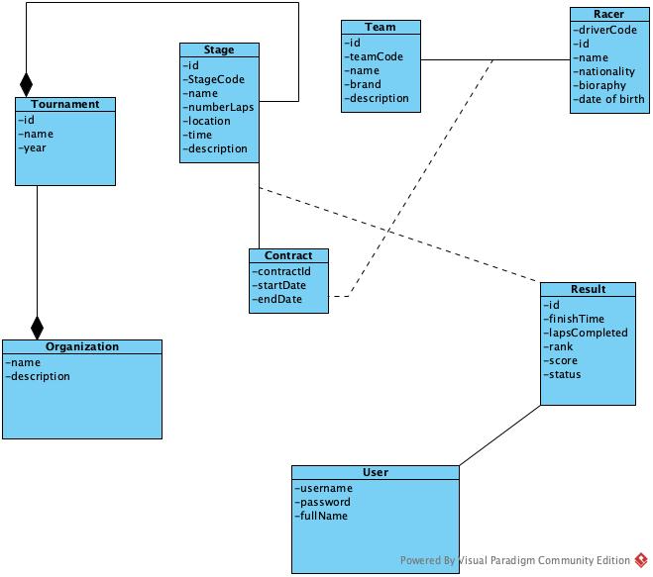

VI. Classes diagram
Analysis this module :
• To login -> The interface to enter credentials appears -> need a class: LoginView
- inputs: username, password
- button: login
- The system validates credentials -> need a method: checkLogin() -> assign to entity class: User.
• After login -> The main interface of the staff is appeared -> need a class: StaffHomeView which has at least:
- an option to choose to update results -> subUpdateResults.
• Choose to update results -> The interface to select a race/stage is appeared -> need a class: SelectRaceView
- (Note: Races are loaded based on the current Tournament belonging to the Organization).
- a drop-down list of races -> outRaceName
- a drop-down list to select a race -> inRaceName
- a button to confirm selection -> subSelect.
• Select a race and click the select button -> The system has to search all registered contracts/racers for that specific stage -> need a method:
- name: getRegisteredRacers()
- input: a stage ID
- output: a list of Racers and their Teams
- -> assign this method to the entity class: Stage.
• The list of registered racers is then returned to (and displayed on) the result input interface -> need a class: UpdateResultView
- racer info (name and team): read only -> outRacerInfo
- time to finish: input text -> inTime
- laps completed: input number -> inLaps
- finished status (Finished/DNF/Accident): input checkbox -> inStatus
- a button to save the results -> subSave.
• Enter the results for all racers and click save -> The system has to calculate the rank, assign the score, record the User who updated it, and save all data into the DB -> need a method:
- name: saveRaceResults()
- input: a list of Result objects (and User ID for tracking)
- output: boolean
- -> assign this method to the entity class: Result.
• After saving to the DB, the system returns to the StaffHomeView.
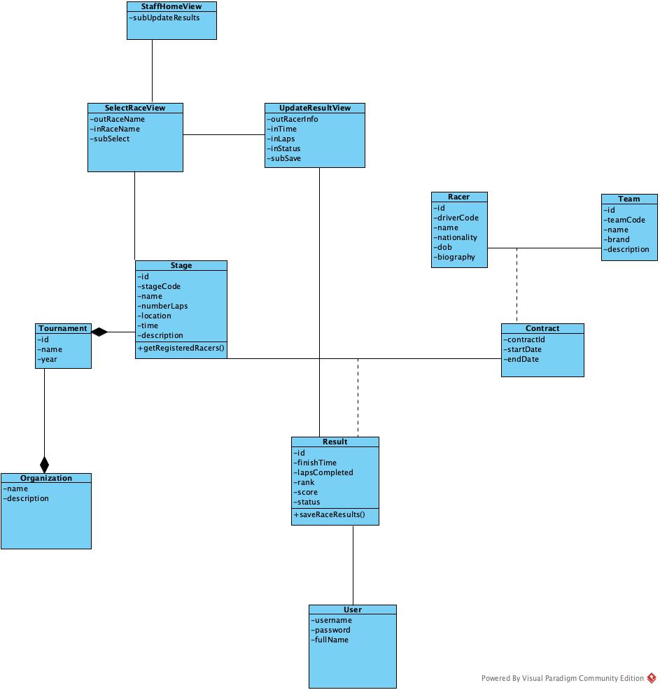
VII. Sequence diagram
Update race results Scenario version 2
- The staff enters username/password and then clicks on the Login button.
- The class LoginView calls the class User to process.
- The class User calls the method checkLogin().
- The class User returns the results to the class LoginView.
- The class LoginView calls the class StaffHomeView.
- The class StaffHomeView displays itself to the staff.
- The staff chooses the option to update results.
- The class StaffHomeView calls the class SelectRaceView.
- The class SelectRaceView displays itself to the staff.
- The staff selects a race name from the drop-down list and clicks on the select button.
- The class SelectRaceView calls the class Stage to process.
- The class Stage calls the method getRegisteredRacers().
- The class Stage returns the results to the class SelectRaceView.
- The class SelectRaceView calls the class UpdateResultView.
- The class UpdateResultView displays the list of registered racers (with blank input boxes) to the staff.
- The staff enters the finish time, laps completed for all racers, then clicks on the save button.
- The class UpdateResultView calls the class Result to process.
- The class Result calls the method saveRaceResults().
- The class Result returns to the class UpdateResultView.
- The class UpdateResultView displays a successful message to the staff.
- The staff clicks on the OK button of the message.
- The class UpdateResultView calls the class StaffHomeView.
- The class StaffHomeView displays itself to the staff.

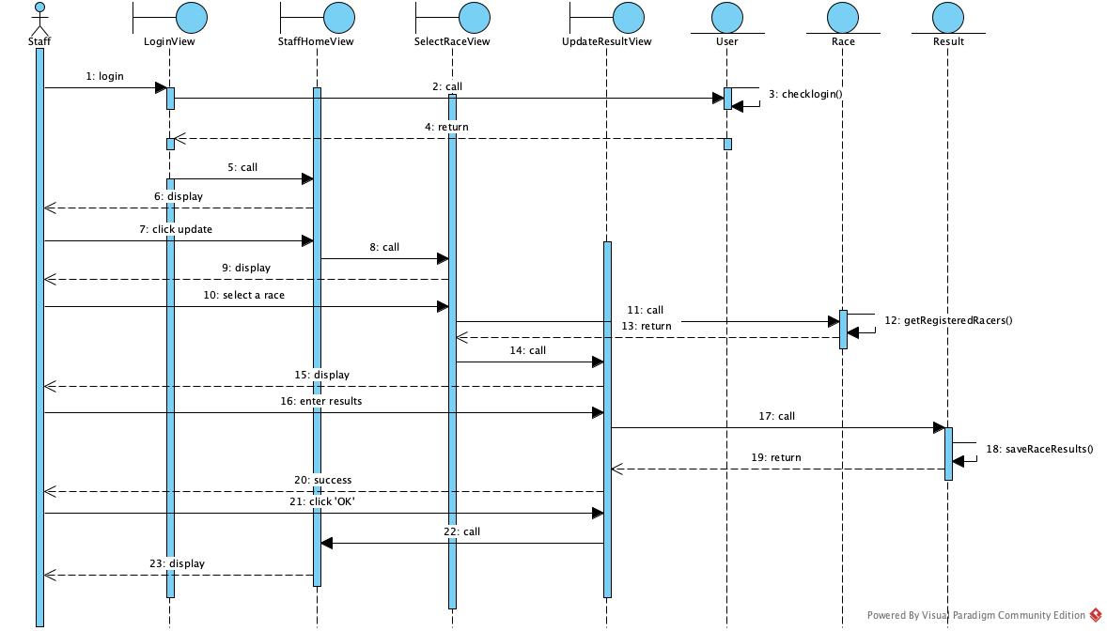

VIII. Design of entity classes
Step 1: Add the id attribute for the classes which DO NOT inherit from other classes. We add the id attribute to the following base classes: Organization, Tournament, Stage, Team, Racer, Contract, Result, and User.
Step 2: Add the type of each attribute in all classes.
- Organization: id: int, name: String, description: String
- Tournament: id: int, name: String, year: int
- Stage: id: int, stageCode: String, name: String, numberLaps: int, location: String, time: Date, description: String
- Team: id: int, teamCode: String, name: String, brand: String, description: String
- Racer: id: int, driverCode: String, name: String, nationality: String, dob: Date, biography: String
- Contract: id: int, startDate: Date, endDate: Date
- Result: id: int, finishTime: String, lapsCompleted: int, rank: int, score: int, status: String
- User: id: int, username: String, password: String, fullName: String
Step 3: Convert all association relationships to correspond aggregation/composition relationships.
- Team + Racer -> Contract is converted to: Team is a component of Contract, Racer is a component of Contract.
- Stage + Contract -> Result is converted to: Stage is a component of Result, Contract is a component of Result.
- User + Result -> converted to: User is a component of Result.
Step 4: Add the object attributes which correspond to the aggregation/composition relationships.
- Tournament is a component of Organization, of type n-1 -> Organization has a list of Tournament
- Stage is a component of Tournament, of type n-1 -> Tournament has a list of Stage
- Contract is a component of Team, of type n-1 -> Team has a list of Contract
- Contract is a component of Racer, of type n-1 -> Racer has a list of Contract
- Result is a component of Stage, of type n-1 -> Stage has a list of Result
- Team is a component of Contract, of type 1-n -> Contract has a Team
- Racer is a component of Contract, of type 1-n -> Contract has a Racer
- Stage is a component of Result, of type 1-n -> Result has a Stage
- Contract is a component of Result, of type 1-n -> Result has a Contract
- User is a component of Result, of type 1-n -> Result has a User

